# CollectionsBase Repository Infrastructure Upgrade

Our high level requirements are laid out in bold below. In italics we have suggested our initial approaches to meeting this requirements, but these approaches are open to further discussion.

**We want to improve the resilience of the infrastructure we use for uploading, storing and querying our CollectionsBase Repository*:* see** [**https://www.orangeleaf.com/museums-archives-history/data-aggregation-system/**](https://www.orangeleaf.com/museums-archives-history/data-aggregation-system/) **This infrastructure is currently based on a single MySQL database and a single Apache SOLR index.**   
*We have been looking at Apache SOLR Master/Slave replication and MySQL replication, with a SOLR master running on a SOLR main server and a MySQL master running on a main web server, with two slave servers both running and MySQL SOLR slave instances. The initial architecture is outline on the diagram on page two – see the CollectionsBase Repository panel. Note: the rest of the infrastructure in this diagram is outside of the scope of this project.*

**We need full and seamless administrator access to the CollectionsBase Repository**

[James, Leigh: can you give more specific details about requirements here..]

**We need a minimum two month period of running the new infrastructure alongside our existing infrastructure to carry out testing. During this period we need the ability to quickly up or downscale the specifications of the environments.**

**We require a formal Service Level Agreement in line with SLA enclosed within this document**

**We want the ability to quickly replicate our live environment in staging and development environments. This may form part of a second phase of the project – but we want this requirement to be borne in mind from the start of the project**

*We have been initially looking at containerisation (e.g. using Docker) as a way of achieving this.*

**We would ideally like the infrastructure to be resilient in the event of total failure at one data centre. Again, this requirement may form part of the second phase of this project – but we want to make sure this requirement is borne in mind from the start of the project**

**We have a long term plan to bring all our infrastructure (which currently includes twenty? WordPress installs, CDN and per customer media server) under the same overall management. This is not part of this initial project, but but we want to make sure this requirement is borne in mind from the start of the project**

## APPENDIX ONE: INITIAL INFRASTRUCTURE

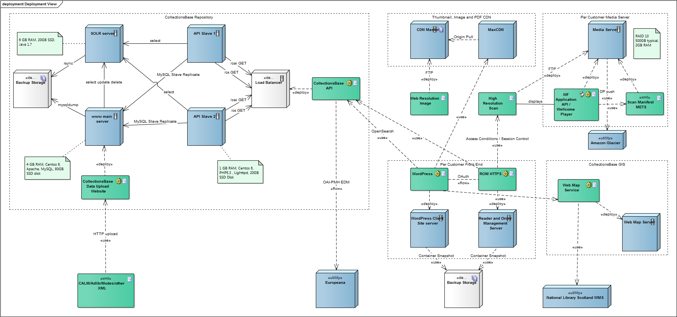

|  |  |  |
| --- | --- | --- |
| EXAMPLE OF SERVICE LEVEL AGREEMENT FOR CUSTOMER WE NEED TO WORK WITHIN | | |
| **The supplier:**   * Is to provide written details of how the service will meet the requirements below. * Is to provide details of the expected performance of the service, providing clear guidance regarding areas in which the assurance cannot be provided. * Can provide any additional information relating to mitigations of the risk of service unavailability. | | |
| **2.a** | The supplier should provide a fully functional and available service **99.5**% of the time, **24** hours a day and **7** days a week, measured **monthly**. For clarification the authority will consider the service not fully functional should poor performance impact upon the usability of the service. |  |
| **2.b** | In addition to uptime the service should not be affected by more than **3** service availability incidents per calendar month. |  |
| **2.c** | The supplier should provide Recovery Time Objectives (RTOs) of less than **18** hours for the service. |  |
| **2.d** | The supplier should provide Recovery Point Objectives (RPOs) of less than **3** hours for the service. |  |
| **2.e** | The supplier should be able to meet authority requests for the restoration of any data up to **1** week after deletion, and specify any time or cost constraints related to the delivery of this capability. |  |

# Service Level Agreements

Provided below are the authority’s standard SLA matrices for all Service Management processes.

| **Incident SLAs** | | |
| --- | --- | --- |
| **Priority** | **Description and Response Times** | **Examples** |
| **I1** | **Major System Disruption**  Response time –15 min  Update – 30 min  Fix time – 2 hours based on a suitable agreed workaround or permanent fix. | A major disruption to the system operability or functionality, server crash or total system failure affecting all users, a business critical function, all core components and/or being public facing.  Loss of ability to run business critical reports, functions or processes as determined by the authority. |
| **I2** | **Severe System Disruption**  Response time – 30 min  Update – 1 hour  Fix time – 4 hours based on a suitable agreed workaround or permanent fix. | A severe disruption to the system operability or functionality affecting multiple users, singular core components or affecting public facing systems. Unable to carry out critical business functions. |
| **I3** | **System Disruption**  Response time – 1 hour  Update – 2 hours  Fix time – 8 hours based on a suitable agreed workaround or permanent fix. | A disruption in functionality that does not impact the entire system such as: Multiple users unable to access the application.  Unable to see a group of data records.  Loss of ability to run any reports. |
| **I4** | **Single Function Failure**  Response time – 4 hours  Update – 4 hours  Fix time – 2 working days based on a suitable agreed workaround or permanent fix. | A minor disruption in operability or functionality that does not impact the entire system such as:  Single user access issue.  Unable to see a single data record |
| **I5** | **Minor / Procedural Issue or Cosmetic Change**  Response time – 6-8 hours  Update – 1 working days  Fix time – 5 working days based on a suitable agreed workaround or permanent fix. | Programming or configuration related issues relating to functionality or operations. Any cosmetic changes to the system due to issues and bugs.  Does not impact on usability. |